Rajiv Dialani

CS-330 Final Project

October 15, 2023

**Reflection**

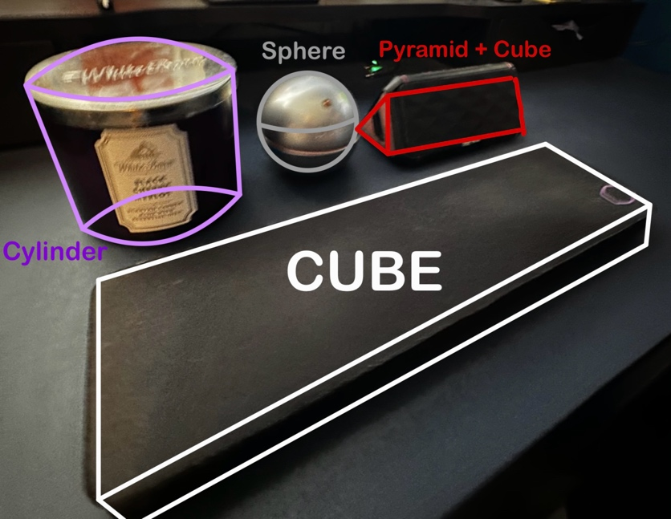

I selected these objects in the beginning of the term with the primitive shapes in mind. I wanted to have one complex object and 3 objects that can be made using one primitive shape. The speaker was made with 2 pyramids at both ends and a manipulated cube as the body of the speaker. The keyboard wrist pad was simply an elongated cube. Texturing the cologne and candle were a little tricky, so I decided to use additional shapes to mimic the 2D scene.

The candle is made with 3 primitive shapes: 2 cylinders and a plane. 1 cylinder is the body of the candle, while the other cylinder is the cover of the candle. I used a plane to display the sticker in front of the candle. Technically, it could have been one cylinder with a proper texture to mimic the logo sticker and the cover. However, I didn’t like that the cover of the candle blending in with the body of the candle, it didn’t have varying depth.

The cologne is made with 3 primitive shapes as well: 3 spheres. 1 sphere to represent the body of the cologne, another sphere to mimic the spout of the cologne, and the last sphere was used to manipulate the orange accent on the body of the cologne. I decided to use this approach to highlight the orange accents found in the bottle of cologne.

The virtual camera for my 3D scene can be controlled using different input devices. The ASWD keys are used to move the camera to the right, down, up, and to the left, respectively. To increase the speed of the camera movement, simply scroll the mouse wheel down. To decrease the speed of the camera movement, scroll the mouse wheel up. I first had the scroll wheel set to mouse sensitivity but having control of the speed of the camera movement seemed more functional. The O and P keys can switch the projection of the scene to Orthographic or Perspective. The mouse can also be used to change viewing angle depending on the position of the mouse.

To make the code more modular and organized, I used several header files, cpp files, and libraries. Using the camera header file provided allowed me to code the navigation and camera movements more cleanly. For the Pyramid Camera assignment, I coded the camera navigation in source.cpp, which made it more congested. I also utilized a mesh header and cpp file that enabled me to access the vertices in a different file, instead of having an additional function with numerous amounts of code in my main function. I just had to change and add certain meshes to ensure it worked with my scene. Using the image loader header file, *stb_image.h*, I was able to easily add my textures with minimal code.

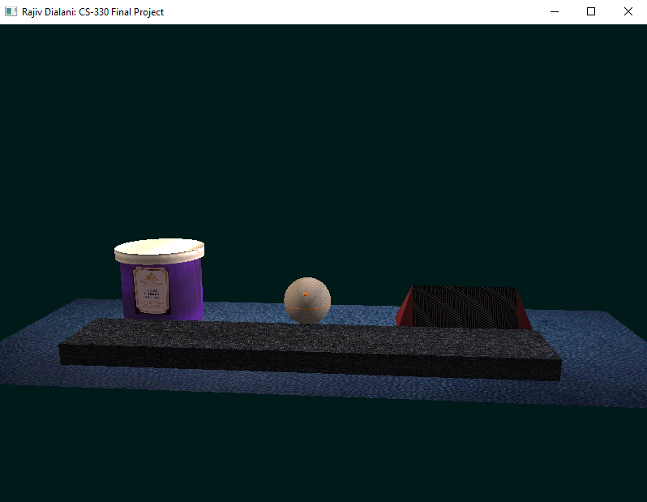Additional angles of my 3D Scene:

